Guidelines for COVID-19 prevention while working in the Shared Instrument Facility (SIF) labs in Benson Hall (121, 123)

If everyone working in the laboratory uses the precautions detailed below, we will minimize the risk of COVID-19 and maximize prevention and safety. Speak up if you observe someone not following such precautions. We are all responsible for stopping the spread of the virus.
A. General guidelines for laboratory personnel safety

1. Never come to campus, the Benson Hall, or a shared facility if you are experiencing any of the following symptoms of infection:
• Fever
• Cough
• Shortness of breath
• Difficulty breathing
• Chills
• Repeated shaking with chills
• Muscle Pain
• Headache
• Sore Throat
• New Loss of Smell and Taste
• Respiratory symptoms

2. Complete a daily attestation of wellness in Workday before coming to work. If you are a non-uw employee, be sure to fill out the attestation on the Chem E department webpage (using your UW ID)

3. If you experience COVID-19 symptoms, are confirmed to have COVID-19, or have someone at home with COVID-19, stay home, contact your healthcare provider, and immediately notify the EH&S Employee Health Center at emphlth@uw.edu or 206-685-1026.
- The identity of individuals who have or may have COVID-19 is handled as protected information.
- EH&S will provide guidance on communicating to staff (as appropriate).
- EH&S will notify individuals who had close contact with the ill person up to 48 hours prior to the development of symptoms.
- EH&S will provide close contacts with public health recommendations that may include staying home and monitoring their health for 14 days.
- EH&S will evaluate the locations where the person spent time on campus for enhanced cleaning and disinfection.

4. If you start showing symptoms of illness while at work, immediately leave the lab, notify EH&S as above, and notify your PI, Kyle Caldwell (kcal@uw.edu) and Debbie Carnes

5. Develop a personal transportation plan that minimizes proximity to other people. Consider cycling, walking or driving instead of public transportation if possible.

6. Be present in the lab only as long as necessary for conducting experimental work. Plan in advance to minimize time around lab members and the general population on campus.

7. Assume that everyone (including yourself) might be an asymptomatic carrier. Use appropriate precautions as transmission may still occur with people displaying no symptoms.
B. Guidelines for working in the SIF Labs (BNS 121 and BNS 123)

- Before traveling to the lab
  - Attest in Workday every day you come to campus. (or fill out the department attestation only if you are a non-UW employee)
  - Sign up for a shift every day using the BNS 121 Lab Occupancy or BNS 123 Lab Occupancy Google Calendars. Briefly describe your planned experimental workflow in the calendar entry (e.g., protein purification). A maximum number of 2 users is allowed in BNS 121 or BNS 123 at any one time. If you cannot make it into the lab, please delete your reservation so we get accurate data on who is in Benson at any given time.
    - When creating the calendar event in the scheduling calendar you must add your own NetID email to that event as a guest so we can track occupancy accurately
  - Book the following shared equipment every day using the Lab Equipment Google Calendar
    - DLS / Zeta Potential (Malvern Zetasizer)
    - HPLC
    - Raman Microscope
    - Rheometer
    - Laser Cutter
    - TGA / DSC
    - UV-Vis
- After arriving to the lab
  - Do not enter unless you are logged in the Lab Occupancy calendar and your usage slot is available.
  - While working in the lab it is recommended that a door stop is used to prop the door open, as to avoid touching the door handle when entering and leaving the labs. Beware of leaving personal belongings unattended while lab/office doors are open.
  - Wash your hands with soap and water upon entering and leaving the lab
  - Increase the frequency of cleaning and disinfecting of high-touch surfaces, such as buttons, handrails, tables, faucets, doorknobs, shared equipment, and shared keyboards. A 70-95% Ethanol solution is recommended (see disinfection guidance)

- While working in the lab
  - Always maintain 6 feet between researchers unless it compromises safety.
  - Adhere to the 6 feet tape markings around the shared equipment, individual workstations, and common work areas as diligently as possible. The boundaries are highlighted in purple, yellow, and orange on the attached floor plan.
  - Minimize the use of shared items (pens, notebooks, frequently used reagent bottles, etc.). As much as possible, each person should have their own. For logging shared instrumentation use, you can email Kyle Caldwell directly with the use time for tracking purposes (kcal@uw.edu)
  - Do not wear gloves and wash your hands after using shared devices like keyboards and lab phones.

- When using shared equipment
  - Allow 10 minutes between usage by different users.
  - Follow existing protocols for safe maintenance and operation.
  - After use, wipedown instruments (including rotors and rotor covers) and marked bench space with paper towels moistened with 70% ethanol (keypads and electronics) or a spray bottle (bench top).
  - Pat dry using paper towels or allow to air dry.

- When leaving the lab
  - Wipe down the work area with 70% ethanol
  - Remove gloves and wash hands with soap and water upon leaving the lab
  - The last person to leave the lab should verify that all equipment is powered down, and any waste generated was stored appropriately.
  - The last person to leave should ensure the lab door is closed and locked, and when they leave the building that the building doors are also locked.

- There should be no guest users in BNS 121 or BNS 123 during this time.
  - New uses must be trained by Kyle Caldwell (email kcal@uw.edu to get trained)

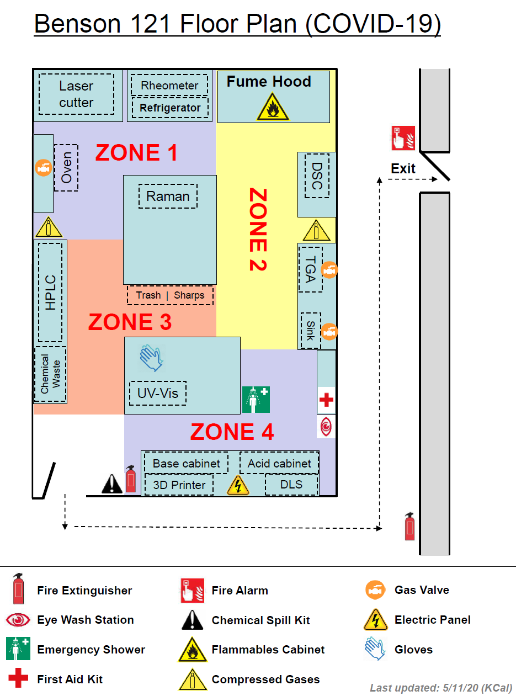
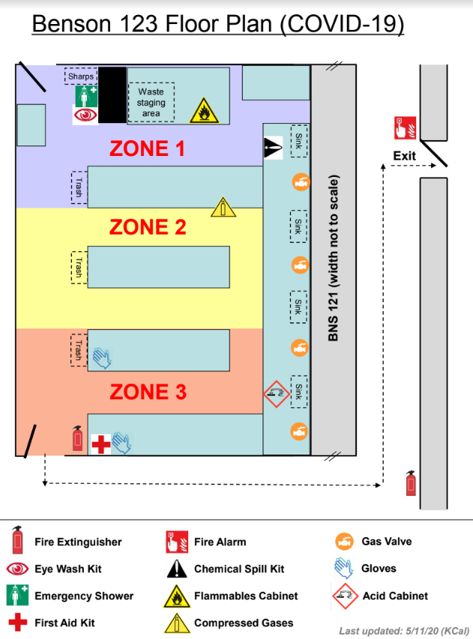
What will happen if a case of COVID-19 is confirmed on site?

If a COVID-19 case is confirmed in the UW community, University units are required to follow the guidance Enhanced Cleaning and Disinfection after Notification of a Confirmed Case of COVID-19 outlined in this document.

On a case by case basis, buildings/rooms where a COVID-19 positive person spent time will be evaluated for a deep clean. Which may take several days.
General guidance for cleaning and disinfection

- Increase the frequency of cleaning and disinfecting, focusing on high-touch surfaces, such as buttons, handrails, tables, faucets, doorknobs, shared equipment, and shared keyboards. Increased frequency of cleaning and disinfecting with attention to these areas helps remove bacteria and viruses, including the novel coronavirus.

2. Practice good hand hygiene after cleaning (and Always!):
• Wash hands often with soap and warm water for at least 20 seconds.
• If soap and warm water are not readily available, use an alcohol-based hand sanitizer that contains at least 60% alcohol.

Safety guidelines during cleaning and disinfection

- Wear disposable gloves when cleaning and disinfecting. Clean hands immediately after gloves are removed.
- Wear eye protection when there is a potential for splash or splatter to the face.
- Lab coats are recommended to protect personal clothing.
- Store chemicals in labeled, closed containers. Store them in a manner that prevents tipping or spilling.

Disinfectant Solutions

10 % Bleach Solution | 100 ml Bleach | 900 ml Water | Allow 2 minutes of contact time and pat dry with towels/ kimwipes
70 % Ethanol Solution | 700 ml Ethanol | 300 ml water | Allow 2 minutes of contact time and pat dry with towels/ kimwipes

Hand hygiene (https://www.who.int/gpsc/5may/Hand_Hygiene_Why_How_and_When_Brochure.pdf)

Signature:
I have read this document, and will adhere to the guidelines listed within while conducting research in BNS 121 or BNS 123.

Signature: ________________________________ Date: _____________________

Printed Name: _____________________________

