UW Chemical Engineering
Autumn 2012

Combinatorial complexity, uncertainty, and emergent behavior in the design of catalytic materials and processes

Dion Vlachos
Elizabeth Inez Kelley Professor of Chemical Engineering and Director of the Catalysis Center for Energy Innovation (CCEI)
Department of Chemical and Biomolecular Engineering, University of Delaware
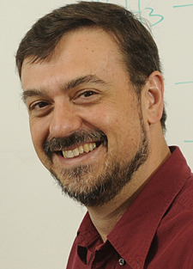 | Date: Monday, Dec. 3, 2012  Time: 4:00 p.m. - 5:00 p.m.  Place: PAA A110
Multiscale simulation is a rapidly growing scientific field in chemical, materials, and biological sciences. The obvious goal of multiscale modeling is to predict macroscopic behavior of an engineering process from first principles (bottom-up approach). However, the emerging fields of nanotechnology and biotechnology impose new challenges and opportunities (top-down approach). For example, miniaturization of microchemical systems for portable and distributed power generation imposes new challenges and opportunities than conventional scale-up. While major progress in multiscale modeling and simulation has recently been achieved, many important problems exhibit combinatorial complexity in parameters (e.g., in developing large reaction mechanisms), an emergent behavior, and complex collective behavior. In addition, the inherent uncertainty in parameter and models makes predictions of multiscale modeling less reliable. In this talk, we will address the aforementioned issues and present examples from biomass processing and hydrogen production for portable power generation.

