

Distinguished Young Scientists Seminar 2012

Extended Ophthalmic Drug Delivery by Soft Contact Lenses
Cheng-Chun Peng
Postdoctoral Scholar, University of California, Berkeley

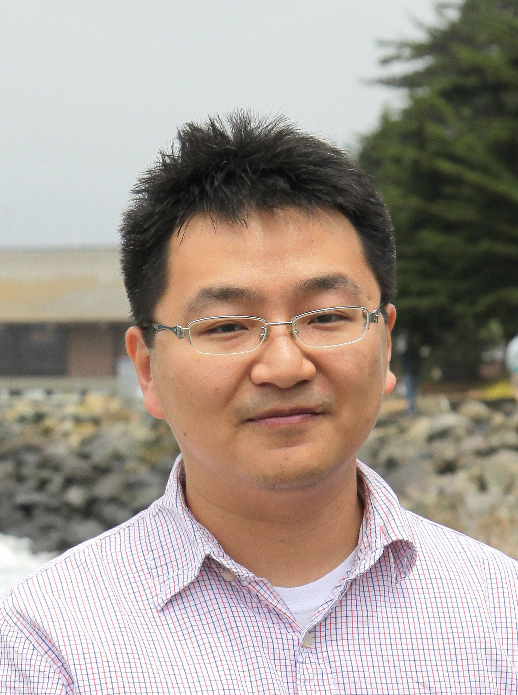
Date: Monday, July 16, 2012

Time: 4:00 — 5:00 p.m.

Place: PAA 102

Traditional ophthalmic drug delivery via eye drops, which accounts for more than 90% of current ocular drug administration, is an inefficient route since only 1-5% of the applied drug enters the cornea, while the rest is drained out and could be absorbed into the bloodstream and lead to side effects. Furthermore, drug administration through eye drops results in a rapid variation in drug delivery rates to the cornea that limits the efficacy of therapeutic systems, limiting patient compliance. The interests of using contact lens as an alternative ocular drug delivery vehicle were triggered by its higher drug bioavailability to cornea. However, commercial hydrogel contact lenses could not provide sufficient transport resistance, and usually release the included drug no longer than a few hours.
Our approach to achieving extended and controlled ocular drug delivery focuses on creating biocompatible transport barriers within commercial hydrogel contact lenses. Drug transport through diffusion-barrier loaded contact lenses depends on the interaction between the barriers and the drug of interest. In this talk, we will focus on using vitamin E as the diffusion-barrier material. The nanosized vitamin E barriers are created in a prefabricated contact lens by soaking the lens in a solution of vitamin E in ethanol, followed by rapid extraction of ethanol in water. The morphology of the vitamin E barriers was explored through direct hyperspectral imaging and indirectly by fitting transport data for hydrophobic, hydrophilic and surface active drugs to models that contain geometric parameters of the barriers as fitting constants. The transport data for several drugs was successfully modeled with the same parameters proving the validity of the approach. The talk will also discuss the impact of the vitamin E barriers on transport of ions and oxygen, and on other properties relevant to contact lenses. Finally the talk will discuss the in vivo animal experiments in glaucoma model of Beagle dogs to deliver a glaucoma drug through the vitamin E loaded contact lenses. Our combination of in vitro, in vitro experiments along with the mathematical models for transport prove that glaucoma and several other ophthalmic diseases can be treated very effectively with contact lenses.

