

Distinguished Young Scientists Seminar 2011

Construction of Synthetic Circuits by Harnessing Orthogonal Genetic Parts
Tae Seok Moon
Postdoctoral Scholar, Department of Pharmaceutical Chemistry, University of California, San Francisco

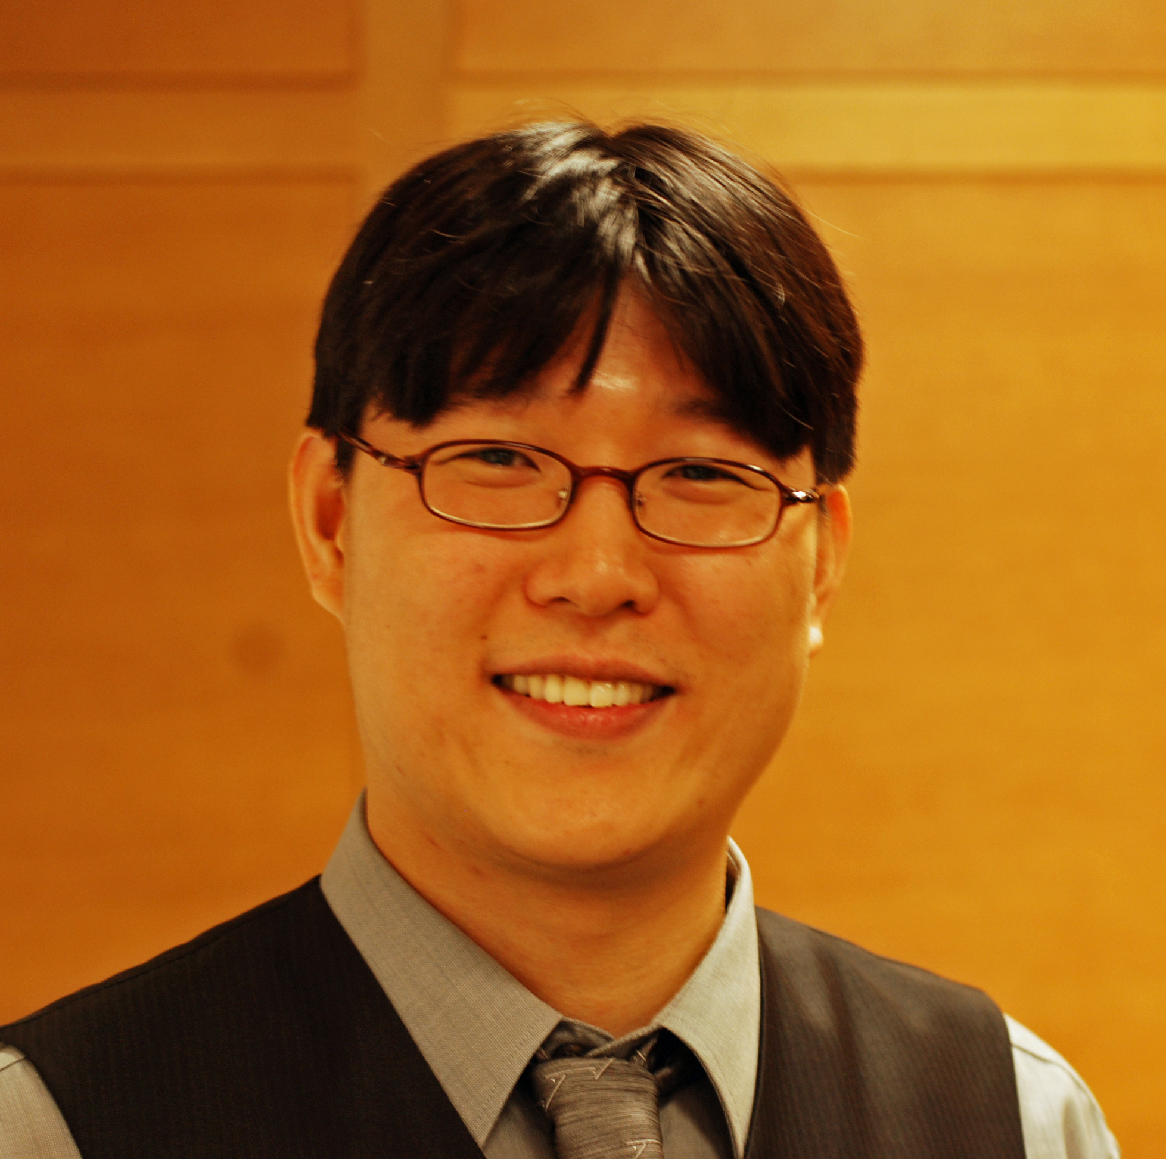
Date: Monday, July 11, 2011

Time: 4:00 — 5:00 p.m.

Place: PAA 102
Many applications require cells to integrate multiple environmental signals and to implement synthetic control over biological processes. Genetic circuits enable cells to perform computational operations, interfacing biosensor modules and actuator modules. Despite advances in the rational construction of genetic circuits, synthetic biologists are still limited by the lack of well-characterized orthogonal parts and predictive computational models. Here, we harness a toolbox of genetic parts from bacteria to construct three 2-input AND gates, a 3-input AND gate, and a 4-input AND gate. To this end, genetic parts have been recruited from Type III Secretion System (T3SS) where activator-chaperone pairs interact to regulate virulence gene expression. Such pairs have been assembled in E. coli and their expression has been tuned by saturation mutagenesis of promoters and RBSs. These engineered 2-input AND gates have been fully characterized, modified (via directed evolution) to make them orthogonal, and rationally combined to make the multi-input AND gates. In addition, transfer function models have been developed to computationally analyze the 2-input AND gates. This work represents a step toward constructing programmed cells that are able to process multiple input signals and to produce desirable outputs for real-world applications.
Tae Seok Moon and Christopher A. Voigt, Department of Pharmaceutical Chemistry, UC San Francisco

