

Distinguished Young Scientists Seminar 2012

A multi-scale systems biology approach with tunable resolution for designing, testing and optimizing new therapies for tuberculosis
Mohammad Fallahi-Sichani
Post Doctoral Research Fellow, Harvard Medical School

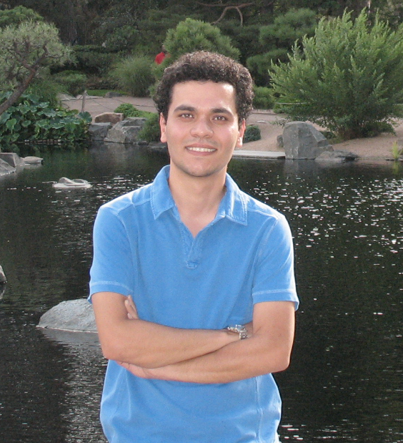
Date: Monday, July 30, 2012

Time: 4:00 — 5:00 p.m.

Place: PAA 102

Despite years of scientific research and efforts, tuberculosis (TB) remains a global health problem and is responsible for ~2 million deaths per year. The pathologic hallmark of tuberculosis is the granuloma. Granulomas are aggregates of immune cells that form in the lung in response to Mycobacterium tuberculosis (Mtb) infection. If granulomas are capable of inhibiting or killing most of the Mtb present, humans develop a clinically latent infection. However, if a granuloma is impaired in function, infection progresses, granulomas enlarge and bacteria seed new granulomas; this results in progressive pathology and disease, i.e. active tuberculosis. In clinical latency, immunologic perturbation at the level of the granuloma can result in reactivation of infection. There is a critical need for novel approaches and platforms for testing and optimizing new therapies for TB.

The roles and interactions of various cells (macrophages, T cells, B cells, neutrophils) and molecules (cytokines, chemokines, effector molecules) within a granuloma are complex and challenging to address by experimental methods alone. Further, appropriate delivery of drugs to granulomas and proper timing, drug combinations and dosing are key factors in a successful therapy, but these are difficult to study in mammalian systems due to cost, technical and ethical issues. Here I explain how a systems biology approach can integrate experimental and computational work to help us: (i) understand the temporal and spatial aspects of granuloma formation and function during the immune response to Mtb, (ii) identify therapeutic targets for controlling infection and inflammation at the level of a granuloma, and (iii) design, test and optimize strategies for therapy. This approach integrates experimental data and processes from a wide range of time (seconds to years) and length (molecules to tissue) scales. An experimental model of a TB granuloma induced in the lungs of mice following injection of mycobacterial antigen-coated beads is used. A multi-scale computational model is developed with a tunable resolution allowing us to fine-grain or coarse-grain the model at will. Thus, the model can be adjusted to vary the degree of detail specific to the questions being asked. This approach is applicable to the studies of other complex disease where there is a need for bridging studies of therapeutic targets at the molecular and cellular scales to the effects of modulation of these targets at the tissue, organ, and whole organism levels.

