UW Chemical Engineering
Autumn 2012

Fueling an Electrochemical Cell for Clean Mobile Energy

Kwong-Yu Chan
Department of Chemistry, The University of Hong Kong

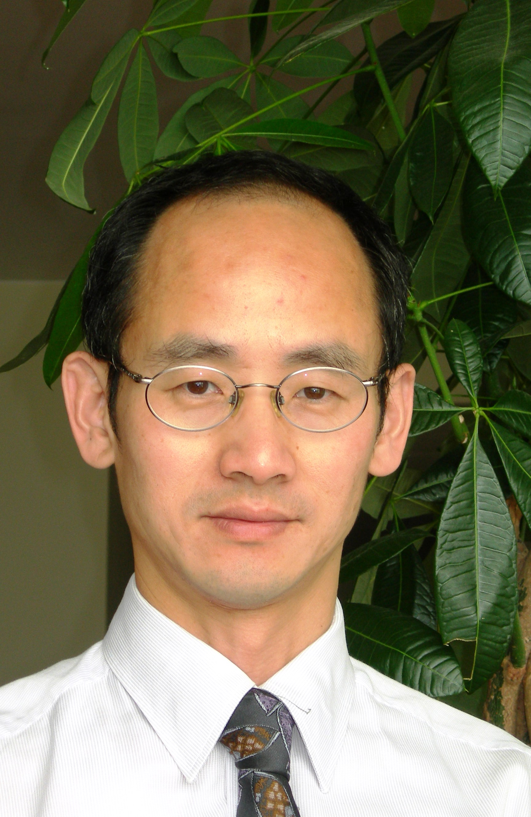 | Date: Monday, Nov. 5, 2012  Time: 4:00 p.m. - 5:00 p.m.  Place: PAA A110
Fuel cells are actively developed to provide portable energy with features of zero emission, high energy density, and rapid re-fueling. In parallel to research of advanced materials for cell components, the technology is searching options of fuels which may require special processing and storage. Hydrogen, the most developed fuel with good kinetics, is lacking satisfactory means of generation and storage. Gases reformed from carbon containing fuels usually contain carbon monoxide which poisons electrocatalysts in a fuel cell.
While hydrogen contained in formic is 4.3 % by mass, its complete release and free of CO makes an attractive option. We present studies of hydrogen generation from formic acid in the presence of a PtRuBiO_{x} catalyst [1,2,3]. Dehydrogenation of formic acid proceeds in aqueous phase at room temperature without carbon monoxide. Hydrogen evolution kinetics shows a low activation energy barrier of 37.3 kJ/mol. A hydrogen generator is shown feeding on formic acid and powering small fuel cell. Using crude models of the catalyst, density functional theory (DFT) calculations are performed [4] to explore the reaction mechanism. Activities of different combinations of metal species are compared.
Carbon monoxide hydration followed by formic acid dehydrogenation gives an overall water-gas-shift reaction. This offers the prospect of using CO as a fuel to generation hydrogen. Using a reactor with two gas chambers sharing a common aqueous phase, we investigate aqueous phase water-gas-shift reaction at 40°C and 2 to 20 bars.
[1] S.W. Ting, S. Cheng, K.Y. Tsang, N. van der Laak, and K.Y. Chan, Chem. Commun., (2009) 7333.
[2] C. Hu, S.W. Ting, J. Tsui, and K.Y. Chan, Int. J. of Hydrogen Energy, 37 (2012) 6372.
[3] S. W. Ting, C. Hu, J.K. Pulleri, and K.Y. Chan, Ind. Eng. Chem. Res. . 51(13) (2012) 4861.
[4] C. Hu, S.W. Ting, K.Y. Chan, and W. Huang, Int. J. of Hydrogen Energy, (2012) http://dx.doi.org/10.1016/j.ijhydene.2012.08.035.

