Date: Monday, May 19
Time: 4:00 - 5:00 p.m.
Place: PAA A110
Topic: How the Dynamics of Vesicle and Capsule Suspensions in Flow May Affect Your Bleeding Time
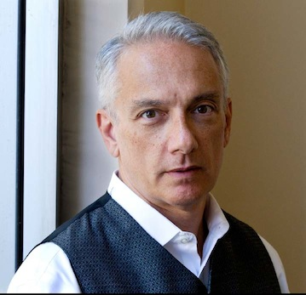 | Professor and Chair Eric S. G. Shaqfeh  Chemical Engineering  Stanford University
Biography
Eric Shaqfeh is the Lester Levi Carter Professor and Department Chair of Chemical Engineering at Stanford University. He joined Stanford’s faculty in 1990 after earning a B.S.E. summa cum laude from Princeton University (1981), and a M.S. (1982) and Ph.D. (1986) from Stanford University. In 2001 he received a dual appointment and became Professor of Mechanical Engineering. He is most recently (as of 2004) a faculty member in the Institute of Computational and Mathematical Engineering at Stanford.
Shaqfeh’s current research interests include non-Newtonian fluid mechanics (especially in the area of elastic instabilities, and turbulent drag reduction), nonequilibrium polymer statistical dynamics (focusing on single molecules studies of DNA), and suspension mechanics (particularly of fiber suspensions and particles/vesicles in microfluidics). He has authored or co-authored over 170 publications and has been an Associate Editor of the Physics of Fluids since 2006.
Shaqfeh has received the APS Francois N. Frenkiel Award 1989, the NSF Presidential Young Investigator Award 1990, the David and Lucile Packard Fellowship in Science and Engineering 1991, the Camile and Henry Dreyfus Teacher--Scholar Award 1994, the W.M. Keck Foundation Engineering Teaching Excellence Award 1994, the 1998 ASEE Curtis W. McGraw Award, and the 2011 Bingham Medal from the Society of Rheology. A Fellow of the American Physical Society (2001) and a member of the National Academy of Engineering (2013), he has held a number of professional lectureships, including the Merck Distinguished Lectureship, Rutgers (2003), the Corrsin Lectureship, Johns Hopkins (2003) and the Katz Lectureship, CCNY (2004). He was also the Hougen Professor of Chemical Engineering at the University of Wisconsin (2004) and the Probstein Lecturer at MIT (2011).
Eric has been married to Terhilda Garrido for 30 years, and they have two children, Stefan, 25, and Elena, 21.
Abstract
It is well known that individual vesicles or liposomes (i.e. fluid enclosed by a lipid bilayer membrane suspended in a second fluid) are characterized by a remarkable dynamics in flow. For vesicles that are “near spheres” this dynamics includes at least 5 different types of orbits in shear flow that are functions of the viscosity ratio between the inner and outer fluid as well as the Capillary number based on the bending modulus. It is therefore not surprising that a suspension of vesicles is characterized by fascinating collective behavior as well. I will discuss our recent development of a numerical code (based on Loop subdivision) which allows the Stokes flow simulation of non-dilute suspensions of vesicles and capsules at essentially any value of the reduced volume. We will then use these numerical simulations to examine a number of interesting phenomena including: 1) The stability of vesicle shapes in extensional flows, 2) The lift of a vesicle away from a wall and the resulting “Fahraeus-Lindqvist” layer for the flow of a wall-bound suspension of vesicles/capsules, and 3) Platelet margination and adsorption in the microcirculation as a function of hematocrit and its relation to bleeding time.

