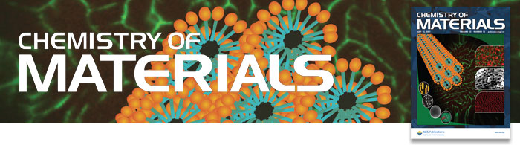
Top 10 Most Read Articles in Q2 2011 & JCR Data
Journal Citation Report Results: Chemistry of Materials received an Impact Factor of 6.397 with 62,879 total citations, as reported in the 2010 Journal Citation Reports ® (Thomson Reuters, 2011).
Articles
Challenges for Rechargeable Li Batteries? John B. Goodenough, Youngsik Kim DOI: 10.1021/cm901452z
Experimental Determination of the Extinction Coefficient of CdTe, CdSe, and CdS Nanocrystals W. William Yu, Lianhua Qu, Wenzhuo Guo, and Xiaogang Peng DOI: 10.1021/cm034081k
Positive Electrode Materials for Li-Ion and Li-Batteries? Brian L. Ellis, Kyu Tae Lee, Linda F. Nazar DOI: 10.1021/cm902696j
Hierarchical Mesoporous Films: From Self-Assembly to Porosity with Different Length Scales Plinio Innocenzi, Luca Malfatti, Galo J. A. A. Soler-Illia
DOI: 10.1021/cm200050r
One-Dimensional Nanostructures of π-Conjugated Molecular Systems: Assembly, Properties, and Applications from Photovoltaics, Sensors, and Nanophotonics to Nanoelectronics? Felix Sunjoo Kim, Guoqiang Ren, Samson A. Jenekhe DOI: 10.1021/cm102772x
Graphene/Polyaniline Nanofiber Composites as Supercapacitor Electrodes Kai Zhang, Li Li Zhang, X. S. Zhao, Jishan Wu DOI: 10.1021/cm902876u
π-Conjugated Polymers for Organic Electronics and Photovoltaic Cell Applications? Antonio Facchetti DOI: 10.1021/cm102419z
Indacenodithiophene and Quinoxaline-Based Conjugated Polymers for Highly Efficient Polymer Solar Cells Yong Zhang, Jingyu Zou, Hin-Lap Yip, Kung-
Shih Chen, David F. Zeigler, Ying Sun, Alex K.-Y. Jen DOI: 10.1021/cm200316s
Earth Abundant Element Cu₂Zn(Sn_{1–}xGex)S₄ Nanocrystals for Tunable Band Gap Solar Cells: 6.8% Efficient Device Fabrication Grayson M. Ford, Qijie
Guo, Rakesh Agrawal, Hugh W. Hillhouse DOI: 10.1021/cm2002836
Preparation and Growth Mechanism of Gold Nanorods (NRs) Using Seed-Mediated Growth Method Babak Nikoobakht and Mostafa A. El-Sayed
DOI: 10.1021/cm020732l
Chemistry of Materials Editor-in-Chief, Len Interrante and 3 Associate Editors (Edwin Chadross, Frank Caruso, and Ferdi Schüth) are co-organizers or plenary
speakers at the Symposium "Challenges for Materials Chemistry in the 21st Century" at the 43rd IUPAC World Chemistry Congress in San Juan, Puerto Rico
July 30 - August 7, 2011.

1155 Sixteenth Street N.W. Washington, DC 20036

